**Data Analyst**: Omosona Alfred

**Data Source**: Google data analytics case study 1

**License**: the license permits me to modify and share findings on this dataset

**Business deliverables;**

These are the questions I answered with the dataset

1. How do annual members and casual riders use Cyclistic bikes differently?

2. Why would casual riders buy Cyclistic annual memberships?

3. How can Cyclistic use digital media to influence casual riders to become members?

**About the company**

In 2016, Cyclistic launched a successful bike-share offering. Since then, the program has grown to a fleet of 5,824 bicycles that are geotracked and locked into a network of 692 stations across Chicago.

The bikes can be unlocked from one station and returned to any other station in the system anytime. Until now, Cyclistic’s marketing strategy relied on building general awareness and appealing to broad consumer segments.

One approach that helped make these things possible was the flexibility of its pricing plans: single-ride passes, full-day passes, and annual memberships. Customers who purchase single-ride or full-day passes are referred to as casual riders.

Customers who purchase annual memberships are Cyclistic members. Cyclistic’s finance analysts have concluded that annual members are much more profitable than casual riders. Although the pricing flexibility helps Cyclistic attract more customers, Moreno believes that maximizing the number of annual members will be key to future growth. Rather than creating a marketing campaign that targets all-new customers, Moreno believes there is a very good chance to convert casual riders into members.

She notes that casual riders are already aware of the Cyclistic program and have chosen Cyclistic for their mobility needs. Moreno has set a clear goal: Design marketing strategies aimed at converting casual riders into annual members. In order to do that, however, the marketing analyst team needs to better understand how annual members and casual riders differ, why casual riders would buy a membership, and how digital media could affect their marketing tactics. Moreno and her team are interested in analyzing the Cyclistic historical bike trip data to identify trends.

**legend**

* Observation
* Recommendation

Upon downloading the Cyclistic monthly dataset for the year 2021, I cleaned the dataset for each of the months using the Microsoft excel spreadsheet (here I filtered out null values and removed duplicates)

I imported the Datasets for each month into the MySQL Database

I needed to query all the Datasets at once so I merged then using the UNION function

and to make it easier for me I exported it as a single table, named it ANUAL and imported it back into the database using the INFILE command

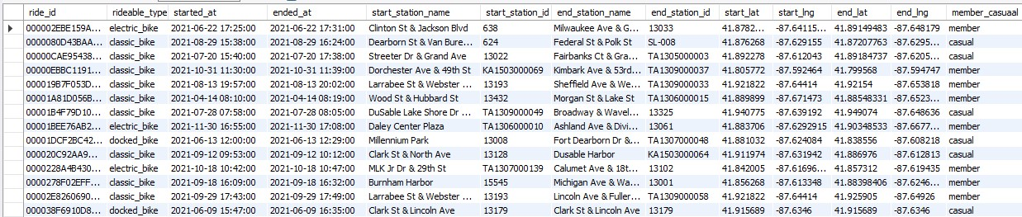

Here is an overview of the dataset



Here’s the total number of records for the year 2021 after the cyclistic dataset was cleaned

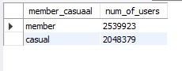

* From this we can see that we had more annual members than casual users, but was that really the case?

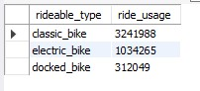

* Here we see that the most preferred or most used type of bike is the classic bike then the electric bike and then the docked bike, now let’s find out which of them the annual members prefer since the goal is to have casual users subscribe for annual membership.

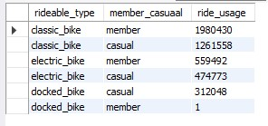

* We see here that annual subscribers prefer or rather mostly use the classic bike and then the electric bike, the docked bike was only used once in the entire year in 2021
* Interestingly casual users used cyclistic bikes in that order although they used the docked bikes almost as much as they used the electric bike

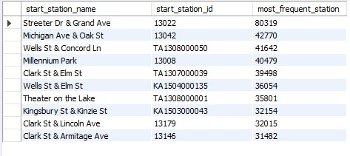

Here is the list of the top 10 stations where users pick up their bikes

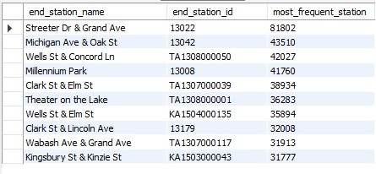

Here is the list of the top 10 stations where user’s drop-off their bikes

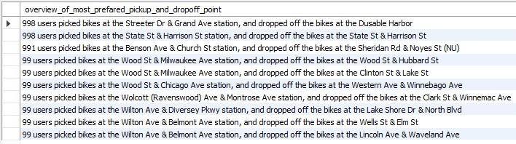

I wanted to see the top 10 most picked up and drop-off point, the obvious reason it doesn’t correlate with what you saw earlier is because users can pick and drop the bikes in any station of their choice

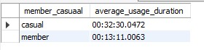

* This is the average time annual and casual user spend on rides, I am about to answer the question I asked earlier
* Earlier it seemed as though we had more annual members than casual users, but here we see that averagely casual users spend more time on rides than annual members, why?

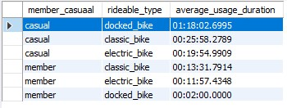

* We see that casual users spend more time on the docked bikes and annul members spend more time with the classic bikes
* annual members frequently used the electric bike and spent more time on it averagely
* casual users frequently used the classic bike but spend more time on the docked bike

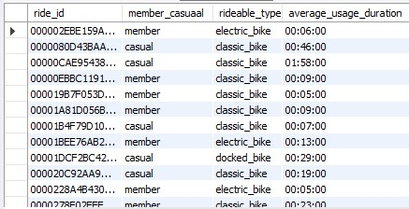

These answers the numerous questions asked earlier

If you pay attention to the table, you would notice that the record entered into the table were according to rides and each ride has a unique ride_id

Based on the above;

* the reason it seems like there were more annual members than casual users is because annual members had more rides than casual user
* casual users spent more time on each ride than annual members
* with further research I found that electric bikes cost more than classic bikes and docked bikes are the least expensive
* and daily pass is for the docked bikes whilst the electric bike and casual bikes are paid for hourly that’s why casual members spend more time on the docked bikes than the other bikes.

**In answering the second and third question**

We have seen the order in which casual users and annual members use cyclistic rides, based on the analysis above we see that they used it in the same order but when it relates to time spent on it they used it in different order

The reason casual riders would buy Cyclistic casual users would want to buy the annual membership

* I recommend a more flexible pricing plan for the classic bike and electric bikes; I won’t affect the profitability of the business because on average annual members spend very little time on rides because they know they can pick up bikes anytime anyway thereby reducing maintenance cost; thus, the maintenance cost will cover up for the added flexibility.
* I recommend that we incorporate an annual pass, more like a swipe card, and since its expected that the company has a record of all the information of its users, the users wouldn’t need to sign any paperwork, but swipe cards and pick up their preferred bike
* The media publicity should reflect the above recommendation as it would not just be a means to get casual users to buy cyclistic membership but also bring in new users to buy the annual membership

.